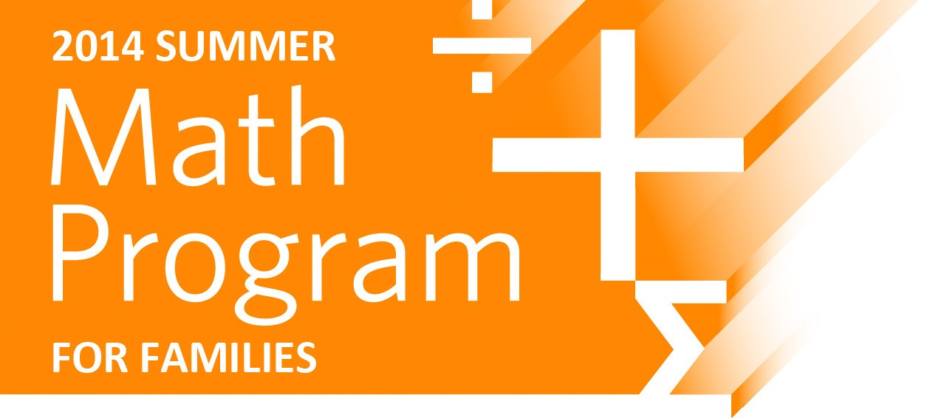
Research shows that summer learning loss in Math is an issue that impacts all students, with students losing an average of 2-3 months of math comprehension
every summer.
TenMarks offers families a proven, scalable, online summer math program to reverse the summer learning loss and help students build a strong foundation in core math skills.
How TenMarks Summer Math Program Works
TenMarks Summer Math Program for students entering grades 2 through Algebra 2 is designed to guide students through a personalized curriculum that meets their specific needs, helping them practice and master concepts with built-in instruction, and real-time intervention.
Designed for the depth and rigor of the new math standards (CCSS and States), every TenMarks assignment ensures students build a strong conceptual foundation, improve problem-solving skills, and gain math confidence.

Reverse Summer Learning
Loss with PREVENTS 2-3 TENMARKS
TenMarks TENMARKS MOVES MATH LOSS IN MONTHS
STUDENTS SUMMER
We Recommend Just AHEAD
20 minutes,
3 times a week
IS ALL IT TAKES.
Personalized for Every Student, Based on Diagnostic Assessment
TenMarks differentiates instruction for every student.
- The program starts each student with a diagnostic assessment taken in school, which results in the automatic creation of an individualized program that adapts to his or her specific needs.
- Each student’s summer curriculum is designed to review concepts from the past year, and get introduced to concepts for the year ahead.

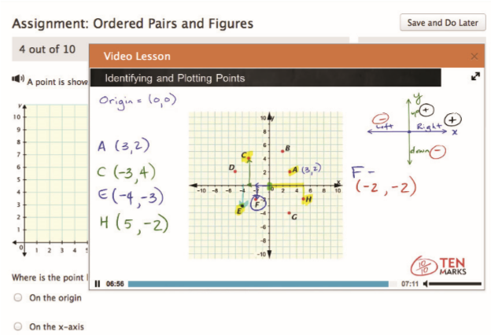
On-Demand Instruction

Facilitates Learning & Success
TenMarks is founded on the principle that support must be embedded, and
delivered the moment students find themselves struggling. When students work on
assignments, they have access to hints and video lessons that help them refresh what
they know, and learn what they don’t. With immediate feedback and just-in-time
assistance, students develop a deep understanding of the concepts covered, leading
to better outcomes.
FREE Summer Math Program for Families
The personalized summer math program is being offered at $0 cost to your family this summer. Students will continue to use their username and password from their classroom.
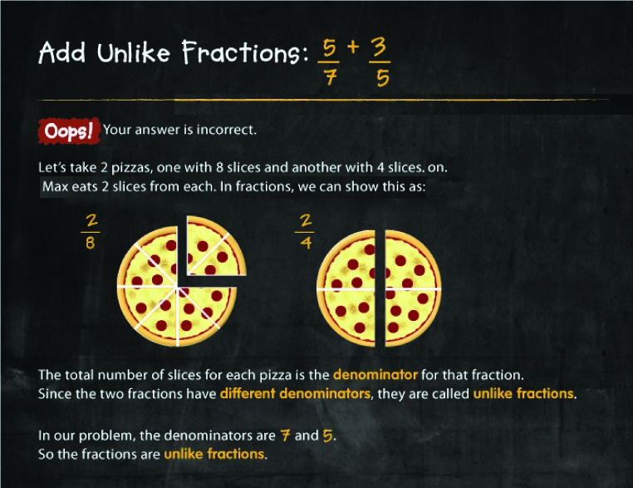

Built-In Interventions
Delivered Automatically
TenMarks has real-time interventions that adapt to a student’s individual needs. When TenMarks recognizes that a student hasn’t mastered a topic, it uses the performance data to diagnose the root cause, and delivers instructional support in a systematic way. Called “Amplifiers”, these adaptive instructional modules help students work through the topic one foundational step at a time, providing bite-sized instruction to fill the required foundational gaps.

Reports & Deep Insights

Based on Analysis
TenMarks provides real-time reports and drill-down insights, so educators can easily monitor usage, proficiency, and performance for each student. The summer program data can also be used to drive improved progress-monitoring during the school year.

Engaging & Motivating

for Students
TenMarks Summer Math Program is engaging for students and enables them to master math concepts with ease. Built-in instruction improves math confidence. Rewards, certificates and games further motivate and engage students.
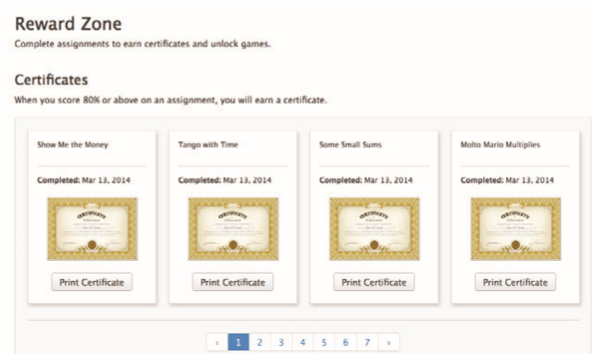

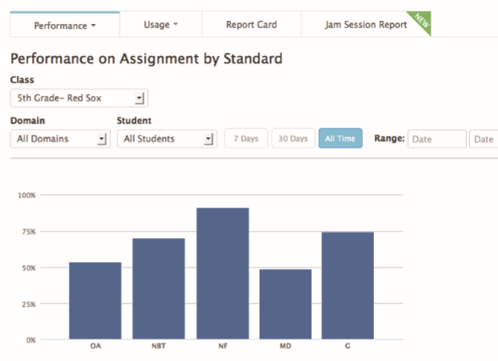
Contact you school principal if you have any additional questions or need for support.

2013
AWARD
Technology Innovation Showcase

