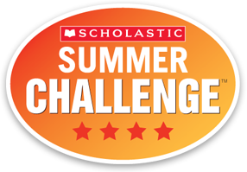
Dear Parents
We are very excited to be part of the Scholastic Summer Reading Challenge. Attached is your child’s log in information for our summer reading challenge. Students should read or be read to 15-20 minutes per day, every day. It is important over the summer that we keep students engaged in reading to continue their emerging skills as young readers. We as a school have set a challenge of reading 200,000 minutes over the summer. I think we can surpass those minutes. We will have a school wide celebration when we return to school for our summer reading program.
Your child will need you to assist them in the first log in because you will need to put in an email address. After that it will be fairly simple for your child to log in and put in their minutes. We are hoping that this will be engaging for your child. Go to http://www.scholastic.com/ups/campaigns/src-2017 to log in and get started.
If you lose your log in information over the summer, please contact me for the information. I will be sending out updates during the summer on how many minutes we have read and to encourage students and parents to log minutes.
A great idea is to pick family novels and read to your children. Children gain from listening to reading and discussing reading. Have your child read books that are at the just right level for their reading for independent reading. All minutes spent reading or being read to count towards our 200,000 minutes.
Thank you
Pat Tolento

